**Excel - latest tips & tricks**



<https://cdn.pixabay.com/photo/2017/12/08/10/35/employee-3005501_960_720.jpg>

Microsoft Excel is not just software; it's a full package of skills. You can't ignore Excel's importance in daily work if you're dealing with a lot of massive data. You can learn how to build a drop-down list in an Excel cell, discover duplicates, eliminate blank rows in Excel, and more by reading these Excel tips and tricks.

So, dive in and satisfy your craving for learning the latest tricks and tips of Excel!!!

1. **One-Click to Select All**

You may be familiar with the Ctrl + A shortcut for selecting all, but few are aware that all data may be selected in seconds with just one click of the corner button, as illustrated in the screenshot below.

1. **Hassle-Free Formatting with Ctl+1**

Ctl+1 is the only shortcut key you need to know for all of your formatting needs. You can pretty much do everything from number formatting to alignment, font to protection, and borders to colors.

1. **Open Several Excel Files at Once**

When you have numerous files to handle, rather than opening them one by one, there is a convenient approach to open them all with one click. Select the files you want to open and then press the Enter key on your keyboard; all of the files will open at the same time.

1. **Gear up Your Speed by Using AutoSum**

When it comes to applying sum formulas to many Columns/Rows, Autosum is another useful tool. This tool allows you to quickly insert a formula into several cells with a single click.

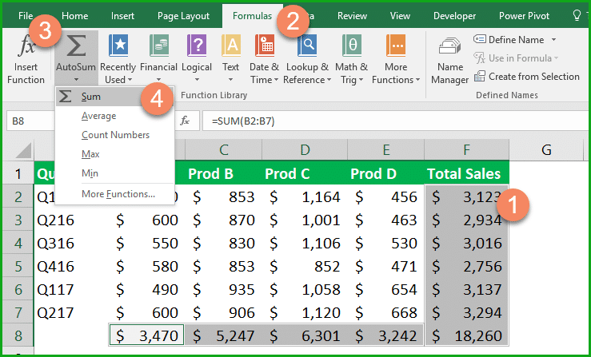

<https://www.settingbox.com/wp-content/uploads/2016/12/Excel-Auto-Sum.png>

1. **Add More Than One New Row or Column**

You may know how to add a single new row or column, but repeating this step X times wastes a lot of time if you need to insert more than one of these. If you want to add X rows or columns above or left, the best technique is to drag and select X rows or columns (X is two or more). Select Insert from the drop-down menu by right-clicking the highlighted rows or columns. New rows will be inserted above the row or to the left of the column you first selected.

1. **Quickly Move and Copy Data in Cells**

If you want to move one column of data in a spreadsheet quickly, select it and move the cursor to the boundary. When the pointer transforms into a crossed arrow icon, drag to freely move the column. What if you need to copy the information? Before dragging to relocate, hold down the Ctrl key; the new column will copy all of the selected data.

1. **Delete Blank Cells Instantly**

For different reasons, certain default data will be blank. Suppose you need to eliminate these to ensure accuracy, particularly when computing the average value. In that case, the quickest method is to filter out all blank cells and delete them all at once. Choose the column you want to filter, navigate to Data->Filter, undo Select All when the downward button appears, and then select Blanks as the last choice.

1. **Quick Filter Techniques**

You can use the quick filter approach to filter data from your active cell by right-clicking on it. You can see an example of how to use right-click to filter the 'Central' region below.

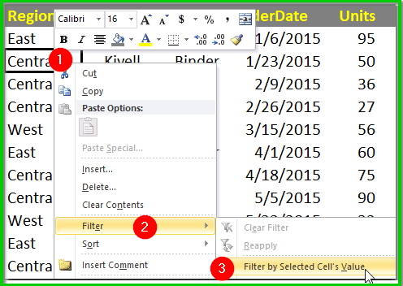

<https://www.settingbox.com/wp-content/uploads/2016/07/quick-filter-technique.png>

1. **Freeze Row and Column Headings**

This is a simple yet effective method for becoming an Excel pro. When you scroll around, freeze the row and column titles so they are always visible. Place the cursor in the top-left cell, where the actual data begins, and pick Freeze Panes and Freeze Panes from the VIEW menu.

1. **Increase Value by Adding Name Range**

In the area of financial modelling, named ranges are quite important. It's frequently regarded as one of the best Excel tricks. You can give your ranges distinctive names and then utilize them in calculations with the help of named ranges. Indeed, no one likes machine code, such as A1:B1, so you can name it whatever you like.

1. **Use Flash Fill to Save Time**

If you're reformatting data in neighbouring columns, flash fill makes things a lot easier. It recognizes patterns and fills in the missing details for you.Simply give Excel a few instances at the top, and the suggestions will appear in grey; hit Enter to accept.

1. **Navigate Fast with Ctrl + Arrow Button**

You can jump to the edge of the sheet in different directions by pressing Ctrl + any arrow key on the keyboard. If you wish to jump to the bottom of the data, use Ctrl + downward.

1. **Use Transpose to exchange Columns and Rows**

You'd use this functionality to transpose data for a better display; however, if you know how to use Paste's Transpose function, retyping all data would be the last thing you'd have to do. Here's how to do it: Move the pointer to another blank position and copy the area you want to transpose. Go to Home->Paste->Transpose (Note: This function will not work until you copy the daemon).

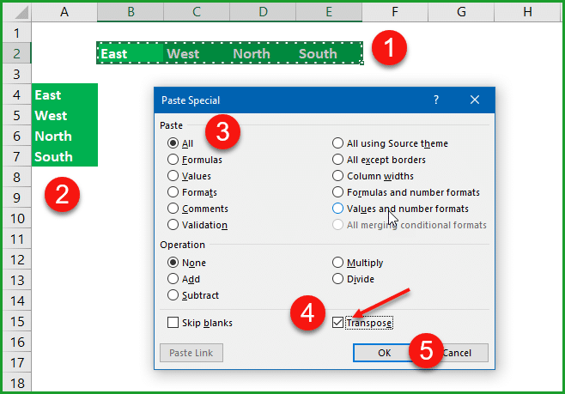

<https://www.settingbox.com/wp-content/uploads/2016/12/How-to-use-excel-transpose-option.png>

1. **Hide Cells Quickly**

Excel has a tricky way of hiding cells. This is one of the most useful Excel hints. Simply select the cell you wish to hide and right-click >choose Format Cells. Under the Number tab, set the format to Custom and enter;;; (three semicolons) as the format. The contents of the cells have vanished, but they are still present and can be used in formulas.

1. **Transforming the Case of Text**

With all of the tips I've offered, I've tried to stay away from intricate formulas. However, there are still several simple and straightforward formulas to demonstrate, such as UPPER, LOWER, and PROPER, which can be used to modify texts for various purposes. UPPER capitalizes all characters, LOWER converts text to all lower case, and PROPER capitalizes only the initial letter of a word.

1. **Add Valuable Comments to Your Formulas**

To leave comments by your formulas for your own reference or assist others in understanding your spreadsheet, add space and +N ("your comment here"). Comments do not appear in the cell, but they appear in the Formula bar and can be searched.

1. **Rename a Sheet Using Double Click**

Renaming sheets can be done in a variety of ways, but most users will simply right-click and select Rename, which wastes a lot of time. The simplest method is to simply click twice, after which you can rename it straight.

1. **Apply Some Conditional Formatting**

In Excel, you may use conditional formatting to make your sheets stand out and make it easier to find data. Select the data that has to be formatted > choose Conditional Formatting (in Home) > and use the drop-down menus to create your rules.

1. **Use AutoCorrect Options to Add Terms and Texts**

Suppose you need to input the same value again and it is difficult to do so. In that case, the best option is to utilize the AutoCorrect tool, which will automatically replace your text with the proper information. Consider your name, John David, which may be shortened to JD. As a result, if you type JD, it will autocorrect to John David. Go to File->Options->Proofing->AutoCorrect Options and input Replace text with correct text in the red rectangular area.

1. **Input Values Starting with ZERO**

This is critical for Excel users frequently. Excel deletes the ZERO by default when any input value begins with zero. Instead of resetting the Format Cells, this issue can be simply fixed by placing a single quote mark before the first zero.

1. **Vague Search with Wild Card**

You may know how to activate the quick search by pressing Ctrl + F, but two main wild cards are used in Excel spreadsheets to initiate a vague search: Question Mark and Asterisk. This is used when you are unsure about the desired outcome. One character is represented by a question mark, whereas an asterisk represents one or more characters.

1. **Quickly Add Up Figures**

You're probably doing a lot of addition in Excel, but you don't have to type out SUM formulas here. Simply select the cell you wish to add at the end of the row or bottom of the column, then press Alt+= ( equals) or Cmd+Shift+T on a Mac.

1. **Add Decimal Points Automatically**

It's not necessary to waste time manually inserting decimal points. The Advanced option is toward the top of the File > Options > Advanced menu. This page contains a number of important settings, including program behaviour, number formats, and much more.

1. **Add Graphics to Charts Easily**

When creating graphics for charts, you don't have to limit yourself to the colored blocks that Excel provides by default. To alter them fill options, simply double-click on a bar and then click paint bucket. You can also use gradients, a pattern, or a file from your hard drive.

1. **Compose Text with &**

The & sign is essential for freely composing any text. For example, you have four columns of text below, but you wish to combine them into a single value in one cell. Then find the cell that will display the composed result, use the & formation, and press Enter. In the F2 cell, the complete text in cells A2, B2, C2, and D2 will be put together.

After reading this article, I hope that you may utilize the tips and tactics to boost your Excel efficiency and complete all of your tasks more rapidly.

So get started with these superb tricks or features and become an Excel pro right away.