**A Quick Excel User Guide**



Excel is a spreadsheet program that appears to have a plethora of features and functions. Excel is not only a tool for storing and organizing data in columns and sheets, but it's also a "what if" machine that can swiftly run a variety of computations with that data.

If you're new to Microsoft Excel, this article is for you. Let's begin our Excel deep dive with the basics in order to work more efficiently and avoid boring, manual effort. You'll be ready to tackle the Excel lessons once you've mastered these functions.

**What is Microsoft Excel?**

Microsoft Excel is a tool that provides worksheets made of rows and columns. Similar to a Microsoft Word table, data can be kept in the worksheet, also known as a spreadsheet, but Excel's strength lies in its capacity to do simple to complicated mathematical calculations and other operations.

**The Excel Worksheet (Spreadsheet) And Workbook**

A spreadsheet, often known as an Excel worksheet, is a two-dimensional grid with columns and rows. The columns are named after letters of the alphabet beginning with A, while the rows are numbered sequentially, beginning with one. A1, B1, C1, and so on are the first row's cells. And the cells in the first column are A1, A2, A3, and so on. These are referred to as cell names or cell numbers.

A workbook is a collection of worksheets or spreadsheets. When the Excel program is opened, a workbook opens with three blank worksheets. The names of the worksheets are displayed on tabs at the bottom of the Excel window.

**How to Use Excel?**

When you launch Excel, it does not start with a blank page. Instead, you'll be taken to Excel's Home page, where you can open an existing spreadsheet or select a template. For quick access, Excel shows spreadsheets you've recently used, pinned, or shared with you. If you often use spreadsheets, you can pin them here on this Home screen, so they're easier to find.

**How to Format Cells in Excel?**

When it comes to formatting and arranging the content of cells, Excel is very similar to Word in many ways. To access common formatting tools such as bold, italic, underline, and font size options, go to the Home tab. Text and cell backgrounds can also be colored and shaded.

You can also automatically snap the column to the width of the widest cell. Position the mouse over the right edge of the cell in the header and double click. The column should adjust — larger or smaller — to the best size to fit the column. Need to move a column from one place in the spreadsheet to another? You can do that, too.

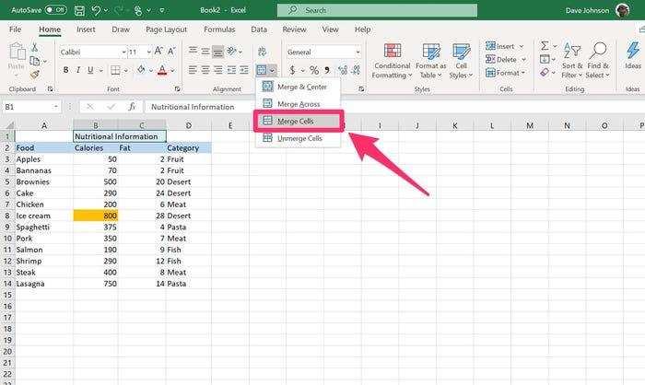

Other frequent formatting chores in Excel include eliminating blank rows to improve the aesthetic of your spreadsheet and hiding rows containing data you need but don't want to show. In a spreadsheet, you can add new rows between rows of current data and even "freeze" a row so that it stays on the screen while you scroll over it.

**How to Insert Rows or Columns?**

As you work with your data, you may discover that you need to add extra rows and columns on a regular basis. It's possible that you'll need to add hundreds of rows at times. It would be quite tedious to do this one by one. Fortunately, there is always an easier option.

To add additional rows or columns to a spreadsheet, select the same number of pre-existing rows or columns as the number of rows or columns you want to add. Then pick "Insert" from the right-click menu.

**How to Use Autofill, Filter and Sort?**

There are several ways to use this feature, but the fill handle is one of the most straightforward. Select the cells you want to be the source, then look for the fill handle in the lower-right corner of the cell and drag it to cover the cells you want to fill or just double-click. When working with enormous data sets (as marketers frequently do), you don't always need to look at each and every row at the same time. You may occasionally just want to look at data that meet particular criteria. Filters have a role in this.

When working with enormous data sets (as marketers frequently do), you don't always need to look at each and every row at the same time. You may occasionally just want to look at data that meet particular criteria. Filters have a role in this. Add a filter by clicking the Data tab and selecting "Filter." Click the arrow next to the column headers, and you'll be able to choose whether you want your data to be organized in ascending or descending order, as well as which rows you want to show.

It's possible that you'll come across a list of data that hasn't been organized in any way. Perhaps you exported a list of marketing contacts or a collection of blog posts. In any case, Excel's sort feature will assist you in alphabetizing any list. Click on the data in the column you want to sort. Then click on the "Data" tab in your toolbar and look for the "Sort" option on the left. If the "A" is on top of the "Z," you can just click on that button once. If the "Z" is on top of the "A," click on the button twice. When the "A" is on top of the "Z," that means your list will be sorted in alphabetical order. However, when the "Z" is on top of the "A," that means your list will be sorted in reverse alphabetical order.

**How to Perform Simple Calculations in Excel?**

To combine numbers in a cell, click the cell and type "=" — this tells Excel that you're entering a formula, and it should try to process whatever follows as a calculation. Then type "1+2+3" into the box. After pressing "Enter," the cell should have the number "6."

To add multiple cells together, put numbers in three nearby cells, such as a 1, 2, and 3. Then, in an empty cell, type "=." Click the first cell with a number in it, press "+" and click the second cell. Press "+" again and click the third cell. Press "Enter." You should see the cell turn into a calculation adding all three cells together.

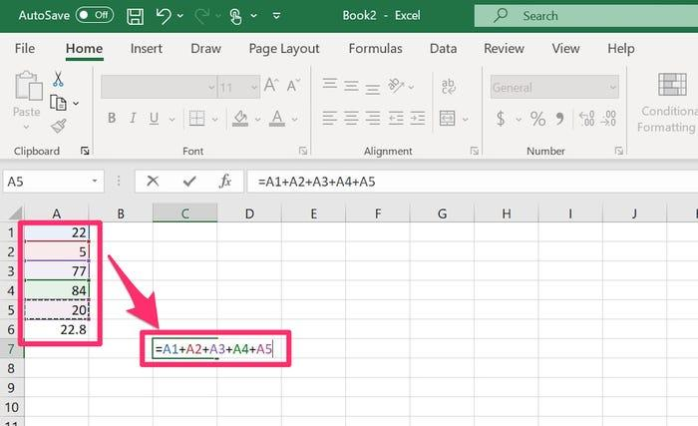

**How to Add All The Cells in A Row or Column**?

Excel makes common computations such as adding numbers in a row or column simple. Click in an empty cell beneath the values you wish to add if you have a row of numbers and want to know the total. Make sure you're on the Home tab of the ribbon before pressing the "Sum" button. The complete column should be selected automatically; if it's not, click and drag the mouse to select the cells you want to add. Press "Enter" and the sum will appear in the cell.

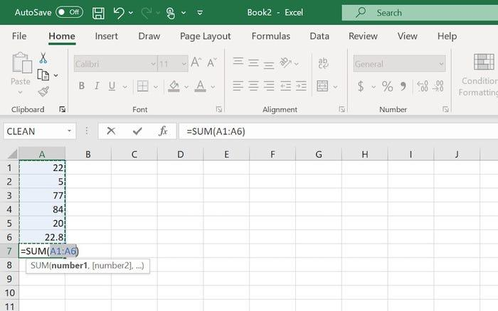

**How to Select Formulas?**

While basic calculations can be done in this manner, Excel contains hundreds of formulae — some familiar, some obscure — that you may use to manipulate the variables in your spreadsheet. Some of them carry out calculations, while others provide data on them. There are two simple ways to use a formula in Excel:

* If you know the name of the formula you want to use, click in a cell and type "=" followed by the first letter of the formula. If you want to find the maximum of several cells, for example, type "=m." A dropdown menu will show all the formulas that begin with the letter M. You can start to spell "Max" or scroll down to find it, then double click "MAXIMUM." Then enter the values to maximum, or select a range of cells you want to perform the formula on.
* You can browse for formulas as well. Click the "Formulas" tab and then click the category you're interested in, such as "AutoSum," ``Financial," or "Math & Trig." Then select the formula you want to insert.

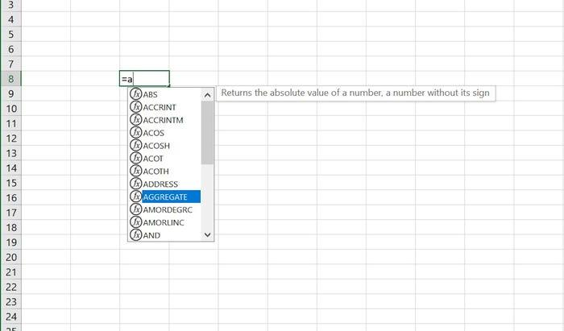

**How to Create A Chart Or Graph?**

The ability to visualize your data by showing it as a chart or graph is one of Excel's most useful capabilities. More than a dozen charts are included in Excel, and they may be made almost instantly by selecting a range of values and a chart from the ribbon. In fact, it's quite simple to make a pie chart or a line graph, and once you've tried your hand at those, other graphs are fairly simple as well.

**How to Create A Pivot Table?**

While pivot tables may appear overwhelming, they are simple to design and provide deep insights into the data in your spreadsheets. They essentially allow you to "pivot" how you view data in a spreadsheet. Click a blank cell in the worksheet with the data you want to visualize. Click the "Insert" tab and then click "PivotTable.Using your mouse, select a range of cells that includes the entire set of data. You should see the selection appear in the "Create PivotTable" box. Click "OK."

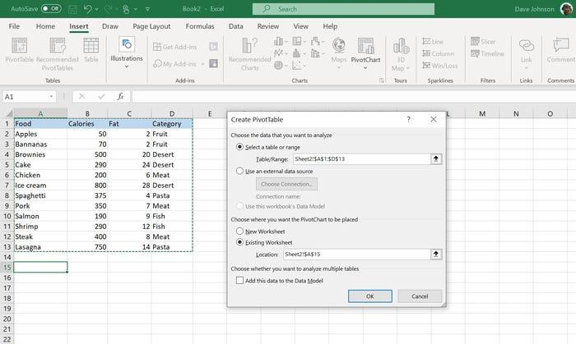

**How to Save And Print A Spreadsheet in Excel?**

Your workbook can be saved to your computer or the cloud. By default, Excel uses AutoSave, which constantly saves your work to OneDrive. You can find the AutoSave control at the top left of the Excel window — swiping it to the right to autosave, or to the left to disable this feature. To save the workbook, click the "File" tab and then choose "Save As" from the File pane. Choose a location and click "Save."

You can also print a worksheet from the File tab as well. In the File pane, choose "Print" and select what you want to print in the Settings section.

Last but not least, Don't be panicked if you see ##### in a cell. It's simply Excel's method of informing you that the column must be made wider in order for the cell contents to appear. Place the cursor on the right side of the column header and drag the column edge to the right until the data appears.

***HAPPY PROGRAMMING!!!***